Producing Reports on Change Requests

Transferring data from CUSMS to Access

- The CRs reports will be produced using basic queries in the CUSMS and downloading the results into the Access.
- Our Access database file already includes tables, queries and reports.
- Our main query in the CUSMS is called ‘Phoenix-mOrder Project’ (owner -‘limor_yarkoni’) which received all the CRs of the ‘Phoenix-mOrder’ project.
Mark the ‘ClearQuality’ in the ‘Apps’ menu and then ‘Select’ -> ‘Change Request Query’.
- The CUSMS query’s results are spilt into a CSV file (Excel) and are loaded by the Access into a MDB file (database).
- The shared and empty MDB file, called ‘mOrderQueries.mdb’ is located in the Perforce – ‘DevDoc\DesignDocs\Apps\mOrder\mOrder1.0’.
- Take the file to your environment and then open the CUSMS ‘Phoenix-mOrder Project’ query (by pressing the ‘Modify’ button).
Then choose ‘File’ -> ‘Save List’ in the menu and save the data in a CSV file (you can choose your own file name).
- Open the ‘mOrderQueries.mdb’ file in the Access: you can see the existing tables, the queries and the reports.

Filling the Access Tables

- Double click on the ‘Phoenix-mOrder’ table.
Then choose ‘File’ -> ‘Get External Data’ -> ‘Import’ and choose the CSV file you just created.
Save the new data.
- The other tables are already full with details and called ‘Members’ and ‘Teams’:
‘Teams’ – includes the team name (like ‘Mira Simovich’ or ‘QA’), the team description (like ‘Order Capturing’) and the team type (‘1’ for mOrder development team and ‘2’ for the other teams).
‘Members’ – the member full name, queue name and owner name and the member team number.
The purpose of the tables is to add the member full names and its team name for the main ‘Phoenix-mOrder’ table, for some reporting usage.
The basic ‘Phoenix-mOrder’ table can contain only the fields that the CUSMS expose, like: queue, owner, priority, type, status, CR id etc. (the severity is now missing but will probably be added later).

Activating the Access queries

- There are two kinds of Access queries:
Update Query - fill tables (marked with exclamation mark and a pencil).
Select Query - read data from tables.
The update queries fill the ‘Phoenix-mOrder’ table: double click first on the ‘Set Team by Owner’ query and then on the ‘Set Team by Queue’ (when a record has both owner and queue, the queue will be ‘stronger’ and will be filled in the team column).
The same with the Member update queries.
The select queries provide cutting data according to every report requirements.
For example: ‘BugListWithoutFixed’ query:

SELECT [Phoenix-mOrder].[ID], [Phoenix-mOrder].[CR ID], [Phoenix-mOrder].[Owner], [Phoenix-mOrder].[Status], [Phoenix-mOrder].[Type], [Phoenix-mOrder].[Priority], [Phoenix-mOrder].[Product], [Phoenix-mOrder].[Title], [Phoenix-mOrder].[Release], [Phoenix-mOrder].[Project], [Phoenix-mOrder].[Milestone], [Phoenix-mOrder].[Queue], [Phoenix-mOrder].[Team], [Phoenix-mOrder].[Member], [Teams].[Type]
FROM Teams INNER JOIN [Phoenix-mOrder] ON [Teams].[Name]=[Phoenix-mOrder].[Team]
WHERE ((([Phoenix-mOrder].[Status])<>"Code Changed" And ([Phoenix-mOrder].[Status])<>"Awaiting Build") And (([Phoenix-mOrder].[Type])<>"Feature Introduction"));

used for example by the ‘BugListWithoutFixed2’ report that eventually will look like that:

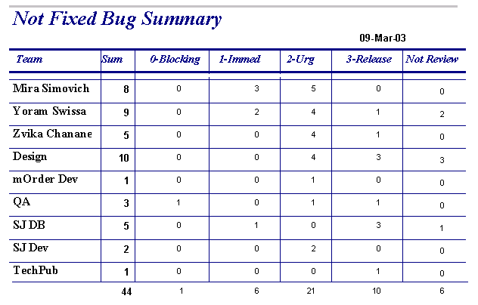

Producing Access Reports

- Reports can be relying on tables (in addition to what already described - on queries) like in ‘BugListIncludingCodeChange ‘ report. This is determined when creating the report.
Existing reports just need to be doubled click.
In case on relying on a query - double click first on the relevant query.

Main Existing Queries and Reports List

Queries:

- ‘BugListWithoutFixed’ – Un fixed mOrder CRs with status that is different then "Code Changed" or "Awaiting Build” and type which is different then "Feature Introduction".
- ‘Order Capture Team by Members’ – The CRs of the Order Capture team members.
The same for every team.
- ‘Other Teams then mOrder or QA’ - CRs of SJ (other teams then mOrder or QA).

Reports:

- ‘BugListWithoutFixedDetails’ – Details of not fixed bugs, per team, with inner groups of priority, sorted by id.
- ‘BugListWithoutFixed2’ – Counting of not fixed bugs, per tea and per priority.
- ‘Order Capture Team by Members’ - CRs details of the Order Capture team members, per team.
- ‘Status per Priority’ – Counting of every CRs status per every priority level and the total amount.

* The queries and reports may be updated.

